Abstract— A mechanistical mathematical model is used to investigate hidden properties of hemodynamics in portal hypertension.
A Computational Model for the Stages of Cirrhosis
Nikhilesh R. Mazumder, Filip Jezek, Dan A. Beard
Clinical Relevance— Cirrhosis progressively scars the liver, leading to increasing blood flow resistance. While the clinical sequelae of such changes have long been known and posited to fit into several stages, a unifying hemodynamic model to explain this framework has not been developed.

introduction
Patients with cirrhosis have progressive increases in venous pressure in the portal system – termed portal hypertension – which can cause collateral shunts from portal vein into the vena cava. Patients with cirrhosis are often asymptomatic until such changes result in an episode of ‘decompensation’ – defined as presenting with significant free peritoneal fluid (ascites) and/or venous shunt rupture (variceal bleeding). The current clinical model categorizes ‘compensated’ cirrhosis as stages 1) No varices, no ascites and 2) Non-bleeding varices, no ascites, with ‘decompensated’ cirrhosis stages 3) Ascites +/- varices and 4) variceal bleeding +/- ascites [1]. Unfortunately, this model falls short clinically as patients do not fall neatly into this progression and may initially present with either significant ascites, variceal bleeding or both. The objective of this study was to determine if a hemodynamic model of splanchnic circulation could better explain varying phenotypes of decompensated cirrhosis seen in clinical practice. We hypothesize that by varying a single parameter – the pressure-diameter responsiveness of the venous shunts – we can simulate the observed phenotypes.

methods
We have employed 0D modeling of the isolated splanchnic hemodynamics (fig 1) with constant throughput. This model consists of resistive components in series (intestinal arteries and veins, liver, hepatic vein) and a model of the peritoneal compartment, following the design of Levitt and Levitt [2]. We have added a compliant porto-systemic shunt, with diameter proportional to its transmural pressure by an arbitral stiffness parameter. With increasing luminal diameter, a large amount of portal vein flow is shunted, altering the splanchnic hemodynamics. Detailed description of the model, including the source codes, is available at [3].
Stages were defined as 1) no ascites present and no varices, 2) varices present > 10 % of the PV flow, 3) ascites volume > 5L and 4) bleeding as Hepatic venous pressure gradient (HVPG) is over 17 mmHg (as observed in [4]).
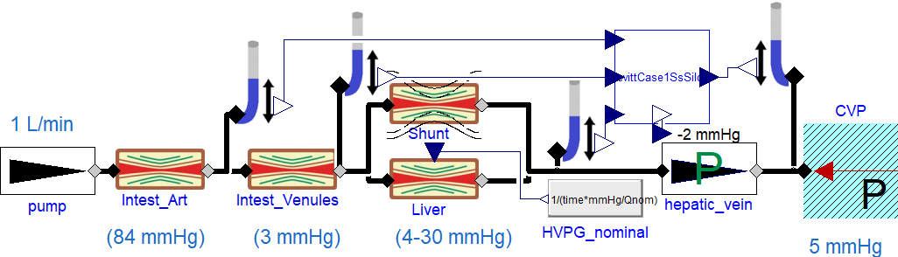
- Model schematics in Modelica language
The output of the model is the veno-caval shunt flow, steady-state ascites volume, portal vein pressure (PPV) and HVPG. We simulated progression of the disease by gradually increasing liver resistance.

RESULT, DISCUSSION & CONCLUSION
Fig.2 shows the predicted cirrhotic clinical stages with respect to increased liver resistance Although the transition happens at same HVPG, the underlying dynamics are whole different (cf. the shunt flow and ascites volume). The results are in agreement with progression of clinical stages in [1] (as about 4% of stage 1 population transition directly to stage 3, compared to 7% transitioning to stage 2 in observed period), while demonstrating two phenotypes of predominant complications, that is the variceal bleeding in case of compliant shunt (fig. 2A) and earlier forming of ascites (fig. 2B) for stiffer shunt.
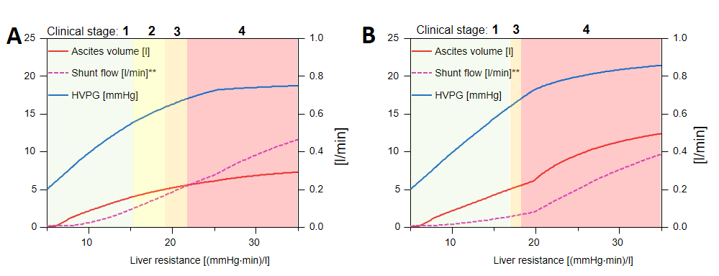
- Simulation of cirrhotic clinical stages for compliant (A)
and stiff (B) porto-caval shunt.
The developed simple model has the ability to describe the different hemodynamic properties associated with cirrhosis on a personalized basis. The developed modeling framework is presented with additional interventions (e.g. trans-jugular intrahepatic shunt, cardiovascular compensations etc.).
References
- G. D’Amico, G. Garcia-Tsao, and L. Pagliaro, “Natural history and prognostic indicators of survival in cirrhosis: a systematic review of 118 studies,” J. Hepatol., vol. 44, no. 1, pp. 217–231, Jan. 2006.
- D. G. Levitt and M. D. Levitt, “Quantitative modeling of the physiology of ascites in portal hypertension,” BMC Gastroenterol., 2012.
- F. Ježek, Ascites: ascites modeling. Github. Accessed: Apr. 04, 2022. [Online]. Available: https://github.com/filip-jezek/Ascites
- D M. Al Mahtab et al., “Hepatic Venous Pressure Gradient Measurement in Bangladeshi Cirrhotic Patients: A Correlation with Child’s Status, Variceal Size, and Bleeding,” Euroasian J Hepatogastroenterol, vol. 7, no. 2, pp. 142–145, Jul. 2017.

  N. R. M.. is with the Division of Gastroenterology and Hepatology and F. J. and D.A.B. are with the Department of Molecular and Integrative Physiology, all at University of Michigan, Ann Arbor, MI, USA; e-mail: fjezek@umich.edu.

